Aaron Robertson, Bill Taylor and Joel Cox

Proposal Chosen: Proposal #19 – Netflix Shows and Movies

Rationale: Perception is changing in the way we watch movies and TV, and we wanted to see how those changes reflect in our data that we collect.

Dataset Links: <https://www.kaggle.com/shivamb/netflix-shows?select=netflix_titles.csv>

<https://trakt.docs.apiary.io/>

<https://www.kaggle.com/ruchi798/movies-on-netflix-prime-video-hulu-and-disney>

Visualization Pictures:

Something similar to this: <https://informationisbeautiful.net/visualizations/the-hollywood-insider/> 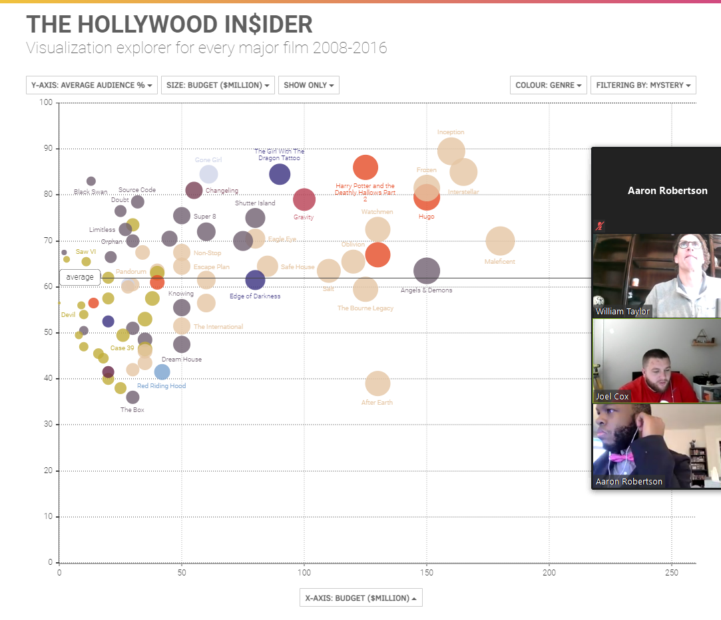

GitHub Repository Link: <https://github.com/doublealogic/project-2-group-f>